FRACK!

A Short Story

New uses for fracking technology and teams

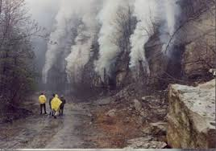

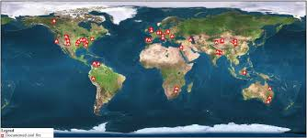

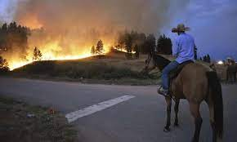

Contents
Frack! 2
Appendix 1 – 3
Appendix 2 – 3

Frack!

Story – What the Frack?

Hey Jo
This is the plan
We're going drilling
Drilling for carbon credits

We drill, right?
We're born to drill.
So, we're doing to do the drilling that helps stop unnecessary emissions.

This is a crazy job and it seems no one is doing it.
But we can.

We're going to get the big fracking rigs, go to these sites with a ton of water

-Don, what are you talking about? Which sites? You've missed a bit... what do you mean?

We're going to put out coal seam fires.
I reckon if we can block the Macondo well, we can put out coal seam fires. They are much shallower.
A directional drillers dream. Might need dozens of Wells.
A great job for us.

-Don’t be daft Don
Who pays for this? No one's been putting out these fires for ever. Why now?

Because world-wide they release 400 million tonnes of co2 every year. For no good reason. There is no gain.
So we'll drill these Wells from the side into the bottom of the seams, store up a load of water, and then big fracking pumps pump in masses of water to flood the bottom of the seam.
This will make a load of steam which will gradually cool down the coal, push out the air and help it go out.
Once it is cool enough, we'll pile in a load of high mineral foam to suppress future fire. There are loads of glass fines we can use.
For the tough Wells we'll add a load of liquid nitrogen if necessary.

-Yeah, yeah
And who pays?

Right..
We get one of these smart climate consultancy crews to write us a set of fancy carbon credit protocols.
The really good credits earn $100 per tonne or more, but even a cheap one might be $5 or $10.
For our purposes, some of the larger sites are doing 100s of thousands of tonnes per year for decades.
At $10 per tonne for a decade of avoided emissions, each site might be worth 10s of millions of bucks.
That's more than we earn on a fracking job.
We get paid for putting out coal seam fires and preventing unnecessary emissions.

We'll start with smaller jobs to learn the necessary skills and extend to progressively larger jobs.
We use satellites to find the sites and assess the emissions & small local seismic to assess the ground
And the down hole temperature tools and other fancy oil field gear
We can totally do this

So we get to drill, and help address the climate crisis.
Top outcome.

Appendix 1 –
https://www.theguardian.com/news/2022/apr/21/uncontrolled-coal-seam-fires-are-catastrophic-polluters?CMP=Share_AndroidApp_Other
The longest-lasting fire known in the world, thought to date back at least 5,500 years, is burning beneath Mount Wingen in New South Wales. The blaze burns in a coal seam that may once have been exposed on the ground and set alight by lightning.

Since then the fire has been smouldering, eating into the coal seam at a rate of about 3ft (1 metre) each year, but because it is about 100ft deep underground the fire is almost impossible to extinguish and will probably continue to burn long into the future.

There are thousands of uncontrolled underground fires in the world, largely coal seams ignited by human-made fires, lightning or spontaneous combustion from chemical reactions.

They are almost impossible to extinguish, threaten many towns, poison the air, soil and groundwater and emit greenhouse gases.

In China there are hundreds of uncontrolled subterranean fires in coal seams, consuming about 18m tonnes of coal each year. The CO2 from these fires adds about 1% to the world’s total greenhouse gas emissions from fossil fuels. Added to all the other coal-seam fires in the world, this is a largely unreported global catastrophe.

Appendix 2 –

https://www.globalforestwatch.org/blog/fires/embers-under-the-earth-the-surprising-world-of-coal-seam-fires/
https://ui.adsabs.harvard.edu/abs/2009EGUGA..1110183W/abstract
https://www.smithsonianmag.com/science-nature/fire-in-the-hole-77895126/
https://en.m.wikipedia.org/wiki/Coal-seam_fire
https://www.sciencedirect.com/science/article/pii/S0166516215300707

